St. John College of Engineering and Management, Palghar

**Department of Computer Engineering**

**A.Y. 2021-2022**

**Group No: 19**

**Group Member Names:** (1)Jagdish Choudhary (2)Anuja Patil (3)Clyde Dsouza (4)Isha Kore

**College E-mail IDs:** (1)[jagdishc@sjcem.edu.in](mailto:jagdishc@sjcem.edu.in) (2)[anujap@sjcem.edu.in](mailto:anujap@sjcem.edu.in) (3)[ishak@sjcem.edu.in](mailto:ishak@sjcem.edu.in) (4)[clyded@sjcem.edu.in](mailto:clyded@sjcem.edu.in)

**Topic 1**

**Domain: Web Application**

**Title of the Project: Online Cake Shop.**

**Problem Statement: Develop a responsive web application for ordering cakes and bakery items. Contains login/sign up, cake cards with cake images info about the cakes, contact us page, payment gateway and some animations. Languages and Database: UI: html, css, javascript and react. Backend: nodejs. Database: mangodb.**

**Proposed Solution (with Block Diagram):**

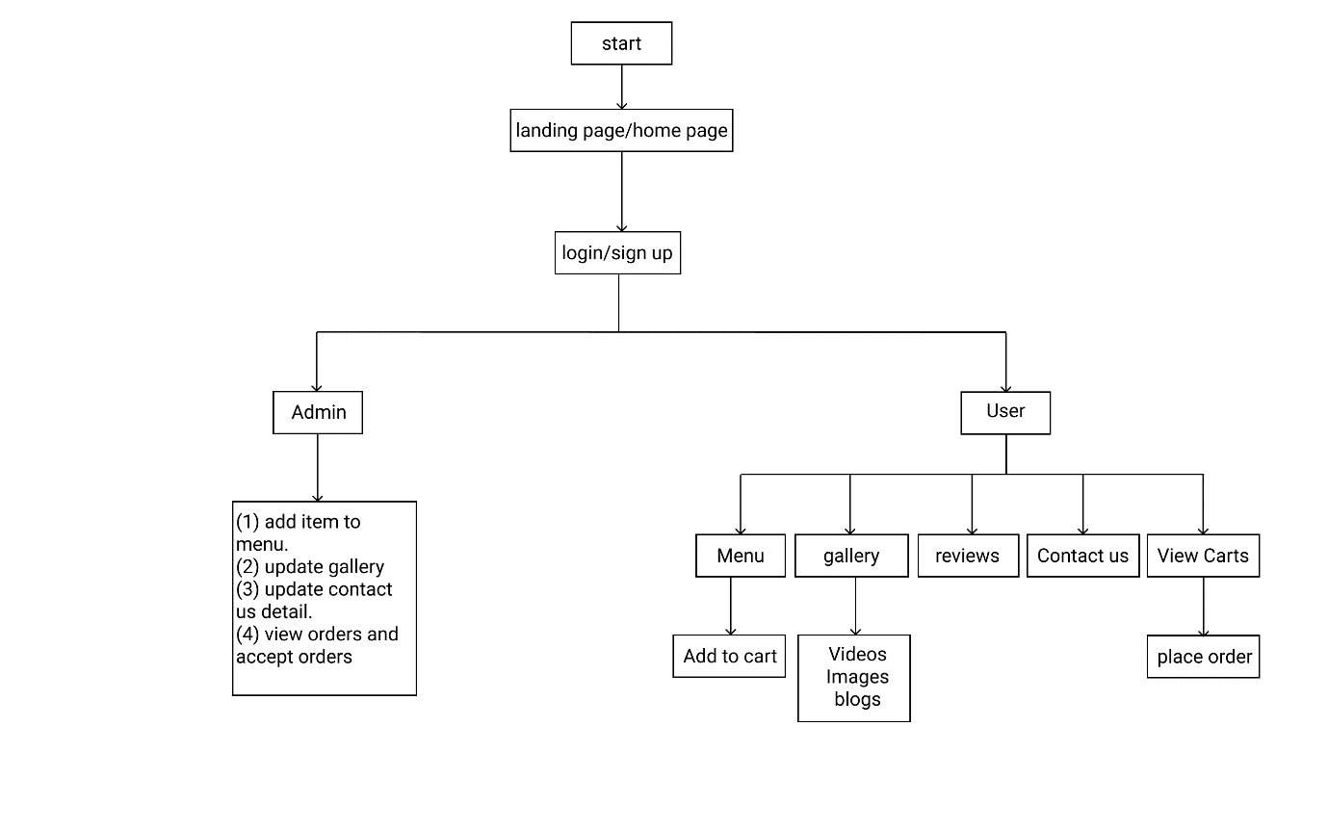

**References (01 base paper [recent one] and other papers):**

**(1) Front End: design and animation from:** [**https://dribbble.com/**](https://dribbble.com/)

**(2) www.orderyourchoice.com**

**ONLY FOR FACULTIES (STUDENTS SHOULD NOT TOUCH THIS SECTION)**

**Reviewer Name:**

**Date of Review:**

**Result:** *(Accept | Reject | Accept with major/minor revisions)*

**Response** (select only 01 from the abovementioned options)**:**

**Reviewer Comments/Suggestions** (at least 03 comments are needed)**:**

(1)

(2)

(3)

(4)

(5)

 

**Group No:19**

**Group Member Names:** (1)Jagdish Choudhary (2)Anuja Patil (3)Clyde Dsouza (4)Isha Kore

**College E-mail IDs:** (1) [jagdishc@sjcem.edu.in](mailto:jagdishc@sjcem.edu.in) (2) [anujap@sjcem.edu.in](mailto:anujap@sjcem.edu.in) (3) [ishak@sjcem.edu.in](mailto:ishak@sjcem.edu.in) (4) [clyded@sjcem.edu.in](mailto:clyded@sjcem.edu.in)

**Topic 2**

**Domain: Web game application.**

**Title of the Project: Space Race Game.**

**Problem Statement: Create a web game contains two player, each controls a rocket. The idea is to get to the top of the map having avoided the space debris to gain a point.**

**Proposed Solution (with Block Diagram):**

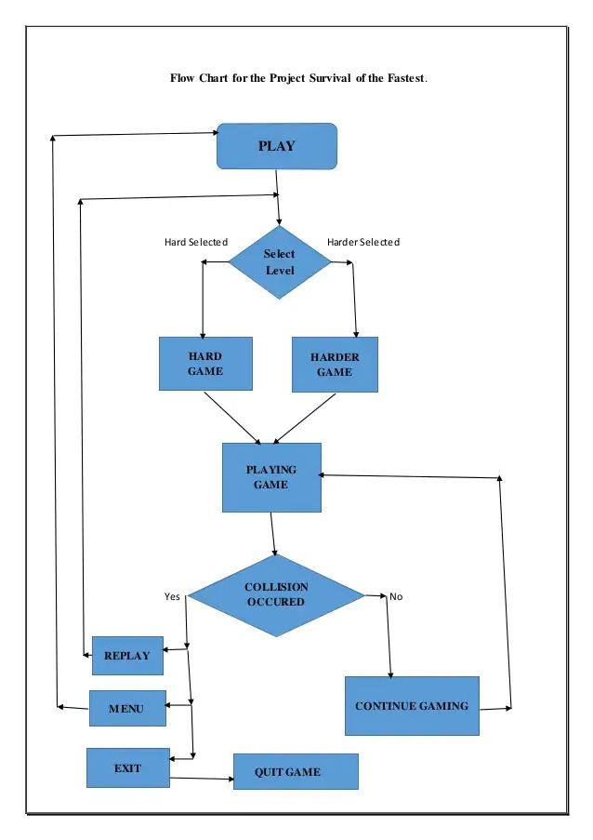

**References (01 base paper [recent one] and other papers):**

**(1) Epicsgames.com**

**ONLY FOR FACULTIES (STUDENTS SHOULD NOT TOUCH THIS SECTION)**

**Reviewer Name:**

**Date of Review:**

**Result:** *(Accept | Reject | Accept with major/minor revisions)*

**Response** (select only 01 from the abovementioned options)**:**

**Reviewer Comments/Suggestions** (at least 03 comments are needed)**:**

(1)

(2)

(3)

(4)

(5)

 

**Group No: 19**

**Group Member Names:** (1) Jagdish Choudhary (2) Anuja Patil (3)Clyde Dsouza (4)Isha Kore

**College E-mail IDs:** (1)[jagdishc@sjcem.edu.in](mailto:jagdishc@sjcem.edu.in) (2)[anujap@sjcem.edu.in](mailto:anujap@sjcem.edu.in) (3)[clyded@sjcem.edu.in](mailto:clyded@sjcem.edu.in) (4)[ishak@sjcem.edu.in](mailto:ishak@sjcem.edu.in)

**Topic 3**

**Domain: Web-based application**

**Title of the Project: Hotel Management System.**

**Problem Statement:** **Hotel management project provides room booking, staff management and other necessary hotel management features. The system allows the manager to post available rooms in the system. Customers can view and book room online. Admin has the power of either approving or disapproving the customer's booking request.**

**Proposed Solution (with Block Diagram):**

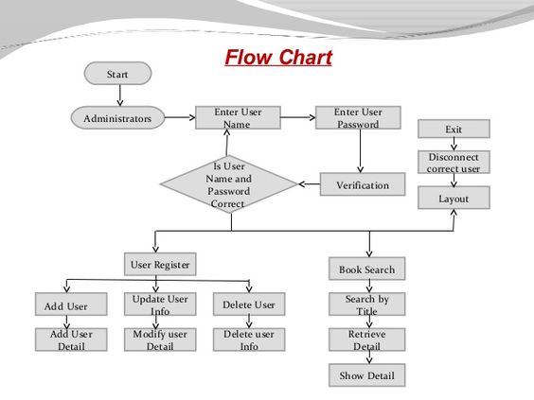

**References (01 base paper [recent one] and other papers):**

**ONLY FOR FACULTIES (STUDENTS SHOULD NOT TOUCH THIS SECTION)**

**Reviewer Name:**

**Date of Review:**

**Result:** *(Accept | Reject | Accept with major/minor revisions)*

**Response** (select only 01 from the abovementioned options)**:**

**Reviewer Comments/Suggestions** (at least 03 comments are needed)**:**

(1)

(2)

(3)

(4)

(5)

 